|  |  |  |
| --- | --- | --- |
|  | | |
| **CAPSTONE PROJECT 1** | | |
| **Project Title: “English For You”** | | |
| **USER STORY DOCUMENT** | | |
|  | **Code**  **Version**  **Date** | **:** E4U  **:**  1.1  **:**  1 - Nov - 2018 |
| **Fantastic 4 Team:**  **Mentor :** Truong Tien Vu  **Member**:Tran Nguyen Huu Nghia  Dinh Tran Anh Truc  Doan Nu Thuc Oanh  Do Van Truong | | |

|  |  |  |  |  |  |
| --- | --- | --- | --- | --- | --- |
| **Project acronym** | Eng4you | | | | |
| **Project Tittle** | [E4U] English For You | | | | |
| **Start Date** | Aug 15, 2018 | | **End Date** | | Dec 5, 2018 |
| **Lead Institution** | International School, Duy Tan University | | | | |
| **Project Mentor & contact details** | Mr. Vu Truong Tien  Email: vudalat@yahoo.com  Tel: 0914083188 | | | | |
| **Scrum Master & contact details** | Nghia ,Tran Nguyen Huu  Email: trannguyenhuunghia97@gmail.com  Tel: 0934848229 | | | | |
| **Team members** | **Name** | **Email** | | **Tel** | |
| Truong, Do Van | [Truongdtct1230@gmail.com](mailto:Truongdtct1230@gmail.com) | | 01674275453 | |
| Oanh, Doan Nu Thuc | [Doannuthucoanh0410@gmail.com](mailto:Doannuthucoanh0410@gmail.com) | | 01674552075 | |
| Truc, Dinh Tran Anh | [Anhtruc2091997@gmail.com](mailto:Anhtruc2091997@gmail.com) | | 0947360347 | |

|  |  |  |  |
| --- | --- | --- | --- |
| **DOCUMENT NAME** | | | |
| **Document Title** | User Story Document | | |
| **Author(s)** |  | | |
| **Role** | Product Owner, Team Member, Scrum Master | | |
| **Date** | 1 – Nov – 2018 | **File name:** | E4U_UserStory_Ver.1.0 |
| **URL** |  | | |
| **Access** |  | | |

|  |  |  |  |
| --- | --- | --- | --- |
| **REVISION HISTORY** | | | |
| **Version** | **Person** | **Date** | **Description** |
| 1.0 | Team | 16 – Sep – 2018 | Draft for comment |
| 1.1 | Team | 1 – Nov – 2018 | Edit and complete |

|  |  |  |  |
| --- | --- | --- | --- |
| **Document Approval**  The following signatures are required for approval of this document | | | |
| **Mentor** | Mr. Truong Tien Vu | **Signature:** |  |
| **Date:** |  |
| **Product owner** | Do Van Truong | **Signature:** |  |
| **Date:** |  |
| **Scrum master** | Nguyen Tran Huu Nghia | **Signature:** |  |
| **Date:** |  |
| **Team member(s)** | Doan Nu Thuc Oanh | **Signature:** |  |
| **Date:** |  |
| Dinh Tran Anh Truc | **Signature:** |  |
| **Date:** |  |
| Do Van Truong | **Signature:** |  |
| **Date:** |  |

Contents

**1.** **Introduction** 6

**1.1.** **Document Overview** 6

**1.2.** **Business Needs and User Needs** 6

**2.** **Use Case of “English For You” System** 7

**3.** **User Story of “English For You”** 7

**3.1.** **US01 – Login into website** 7

**3.2.** **US02 – Log out website** 7

**3.3.** **US03 – Play Game** 8

**3.4.** **US04 – View Game Information** 8

**3.5.** **US05 – View Result** 8

**3.6.** **US06 – Select Key Word** 9

**3.7.** **US07 – Explain** 9

**3.8.** **US08 – Answer** 9

**4.** **Table User Story’s Priority** 9

1. **Introduction**

In the field of software development, User Story (User Stories) is one or more sentences describing natural language (not technical language) or business language of the end user or system user to record what the user needs to do or not to do as part of their job or task. User stories are used in methods like Agile software development is the basis for determining the functions of the system are business development and create favorable conditions for requirements management. Help yourself to know the “who”, “what” and “why” in a simple request, short, often only limited by what details can be written on a piece of paper notes, small scrap paper.

User story is written by business users as the primary way users because they understand most of the process, work flow and functionality of the system should be working now. User story can also be written by developer to express non-functional requirements (such as security, performance, quality)

* 1. **Document Overview**
* This document provides a user story and goal-oriented view of the English For You. Review project which delivers several key project benefits below:
* It helps answer the question “What does this project do?” for the business, project sponsors, developers and architects including clearly defining scope.
* It supports to define target and future state architectures.
* It helps understand required capabilities to support a project.
* It provides a meaningful resource which can be used in conversation between the business and architecture team.
  1. **Business Needs and User Needs**

**Business needs:**

* Take initiative time to learning ( learning whenever they want)
* Communication with foreign to raise English skill
* Didn’t afraid when wrong
* An website can learning English and entertainment
* Interactive, co-operate with other people to learning English

**User needs:**

The “English For You” will benefit user:

* Save on study costs and travel time
* Effective learning but still highly entertaining
* Flexible time and place
* Rich documentation and extensive repository

1. **Use Case of “English For You” System**

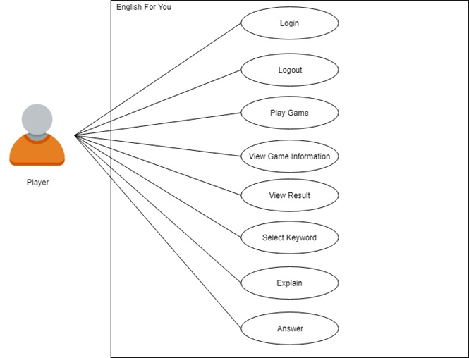

1. **User Story of “English For You”**
   1. **US01 – Login into website**

|  |  |
| --- | --- |
| **As a Users**  **I want to** access to the website by my account **so that** I can use the website. | |
| **Login** | **Project:** English For You |
| **Actor:** Users | **Date:** 09 - Sep – 2018 |
| **Story:** Users want to access to the website by English For You account | **Acceptance Criteria**  - Users can login into system when User click on [Log in with Facebook] button.  - Generate failure or success messages when processing. |

* 1. **US02 – Log out website**

|  |  |
| --- | --- |
| **As a** **Users**  **I want to** logout system **so that** I can stop using website when I click on Logout button and I can login later. | |
| **Logout** | **Project:** English For You |
| **Actor:** User | **Date:** 09 – Sep – 2018 |
| **Story:** User want to logout website | **Acceptance Criteria**  - User can logout system when User click on [Logout] button. |

* 1. **US03 – Play Game**

|  |  |
| --- | --- |
| **As a Users**  **I want to** play game **so that** I can know what’re functions does website have. | |
| **Change Password** | **Project:** English For You |
| **Actor:** User | **Date:** 09 - Sep – 2018 |
| **Story:** User wants to play game | **Acceptance Criteria**   * Log in to website. * Click [Play] button. |

* 1. **US04 – View game information**

|  |  |
| --- | --- |
| **As a Users**  **I want to** see game information **so that** I can know which group i belong, who my play is, how much time i have to play, and how many points i have achieved. | |
| **Change Password** | **Project:** English For You |
| **Actor:** User | **Date:** 09 - Sep – 2018 |
| **Story:** User wants to see game information | **Acceptance Criteria**  - Log in to website.  - Click [Play] button. |

* 1. **US05 – View game information**

|  |  |
| --- | --- |
| **As a Users**  **I want to** see the result **so that** I can know how many points i have achieved, which team wins. | |
| **Change Password** | **Project:** English For You |
| **Actor:** User | **Date:** 09 - Sep – 2018 |
| **Story:** User wants to see the result. | **Acceptance Criteria**  - Log in to website.  - Click [Play] button. |

* 1. **US06 – Select Key Word**

|  |  |
| --- | --- |
| **As a Users**  **I want to** select key word **so that** I can guess and get point easier. | |
| **Change Password** | **Project:** English For You |
| **Actor:** User | **Date:** 09 - Sep – 2018 |
| **Story:** User wants to select key word | **Acceptance Criteria**  - Log in to website.  - Click [Play] button.  - Choose the key word. |

* 1. **US07 - Explain**

|  |  |
| --- | --- |
| **As a Users**  **I want to** explain **so that** my teammate can guess the key word easier. | |
| **Change Password** | **Project:** English For You |
| **Actor:** User | **Date:** 09 - Sep – 2018 |
| **Story:** User wants to explain | **Acceptance Criteria**  - Log in to website.  - Click [Play] button.  - Choose the key word.  - Enter explanation at chat form and click [Chat]. |

* 1. **US08 - Answer**

|  |  |
| --- | --- |
| **As a Users**  **I want to** answer/guess the key word **so that** I can get the point for my team when my answer is right. | |
| **Change Password** | **Project:** English For You |
| **Actor:** User | **Date:** 09 - Sep – 2018 |
| **Story:** User wants to answer | **Acceptance Criteria**  - Log in to website.  - Click [Play] button.  - Enter answer at chat form and click [Chat]. |

1. **Table User Story’s Priority**

***Table 1: User Story Priority***

|  |  |  |
| --- | --- | --- |
| **User Story ID** | **User Story Name** | **Priority** |
| US01 | Login into system | Low |
| US02 | Logout system | Low |
| US03 | Play Game | High |
| US04 | View Game Information | Medium |
| US05 | View Result | Medium |
| US06 | Explain | High |
| US08 | Answer | High |